**EXPERIMENT 9 Date: 31st March 2023**

**TITLE:** **Group by & Having clause**

**OBJECTIVE:** To understand the use of group by and having clause.

**Write SQL Queries for the following queries (use EMP and DEPT table of previous experiment).**

1. **List the Deptno where there are no emps.**

SELECT deptno FROM Emp GROUP BY deptno

HAVING COUNT(empno) = 0;



1. **List the No.of emp’s and Avg salary within each department for each job.**

SELECT COUNT(empno) AS TotalEmp, AVG(sal) AS AvgSal,

deptno, job FROM Emp GROUP BY deptno, job;

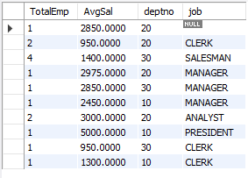

1. **Find the maximum average salary drawn for each job except for ‘President’.**

SELECT MAX(sal) AS MaxAvgSal FROM Emp WHERE sal IN

(SELECT AVG(sal) AS AvgSal FROM Emp WHERE

job != "President" GROUP BY job);



1. **List the department details where at least two emps are working.**

SELECT * FROM Dept WHERE deptno IN

(SELECT deptno FROM Emp

GROUP BY deptno HAVING COUNT(empno) >= 2);

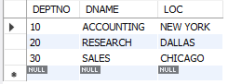

1. **List the no. of emps in each department where the no. is more than 3.**

SELECT COUNT(empno) AS TotalEmp, deptno FROM Emp

GROUP BY deptno HAVING COUNT(empno) > 3;



1. **List the names of the emps who are getting the highest sal dept wise.**

SELECT ename, deptno, sal FROM Emp

WHERE sal IN (SELECT MAX(sal) FROM

Emp GROUP BY deptno);

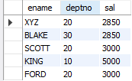

1. **List the Deptno and their average salaries for dept with the average salary less than the averages for all departments.**

SELECT deptno, AVG(sal) FROM Emp

GROUP BY deptno HAVING AVG(sal) <

(SELECT AVG(sal) FROM Emp);

